A PORTRAIT OF MY LOVE
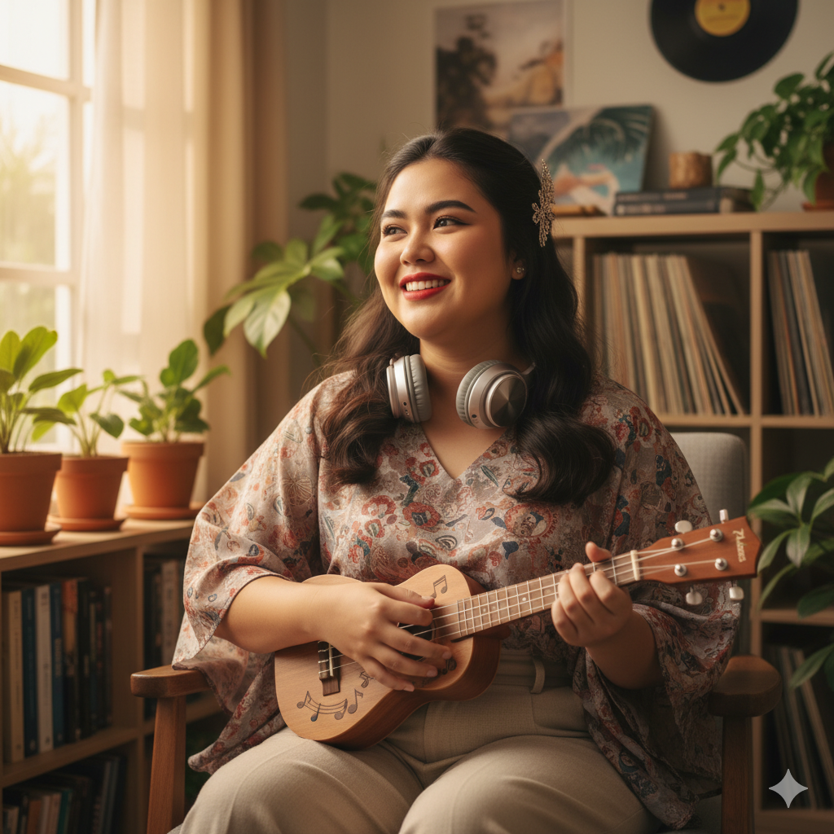

Someone who loves music and generates her own world through music. Her skin should be a fair looking skin. Brown eyes with thick eyebrows with a heavy feminine appearance. Her passion for music should reflect her character very much. Someone also knows how to play instrument like guitar, ukulele or any other kind of musical instrument. She has a slightly chubby appearance because I believe that we should not judge someone by their weights like a typical “Juans” in our country. And also someone who can reciprocate my love.

